Age Group | () |  | For the attention of | ()
All |  |  | Headteacher
Primary |  |  | Bursar/Admin
Secondary (inc Middle) |  |  | Other - Please specify ………………………..
Special |  |  | Other - Please specify ………………………..
Further Education

From
Add your name & job title/team name

Subject title
15 words maximum

Short overview
45 words maximum

Message

Action

Staffordshire County Council
School Bag Guidance

- The school bag enables information to be shared with schools in a single place and reduces the number of emails sent

- The school bag is published most weeks on the Staffordshire Learning Network (or SLN). It is accessible to all schools and officers, via a log-in.

- Please note, we will not accept advertising from charities or businesses or requests for the same proforma to be repeated in successive weeks

- The normal deadline for submission of the proforma is 12 noon on Thursday, for publication on Friday afternoon. The school bag is published during term-time (but check the submission/publication timetable on Staffs Space)

Guide for completion of the proforma

All fields must be completed

Age Group
- Tick as appropriate

For the attention of
- Tick as appropriate

From
- Add your name & job title/team name

Subject title (maximum 15 words)
- As shown below, please keep the subject title concise

Overview (maximum 45 words)
- As shown below, this provides a brief explanation for schools

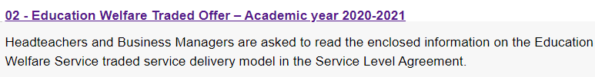
Figure 1: An example of how the items are listed on the SLN, showing the subject title and overview
Message
- The message is the body of the bulletin
- Try and limit to 6-8 paragraphs

- Do not embed documents into the proforma
- If you wish to include a letter or document/s for schools it must be emailed to schools.bulletins@staffordshire.gov.uk, not embedded in the proforma
- Please check that weblinks can be accessed by schools and others

Action
- Include any action/s for schools to take
- If there is no action, then you could state “For Information”

