Sustainable Drainage Systems (SuDS) Handbook

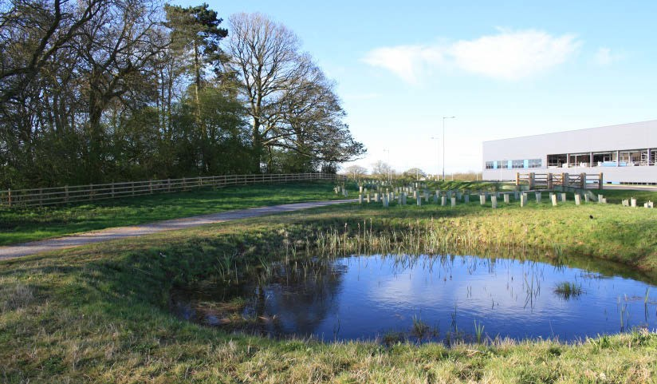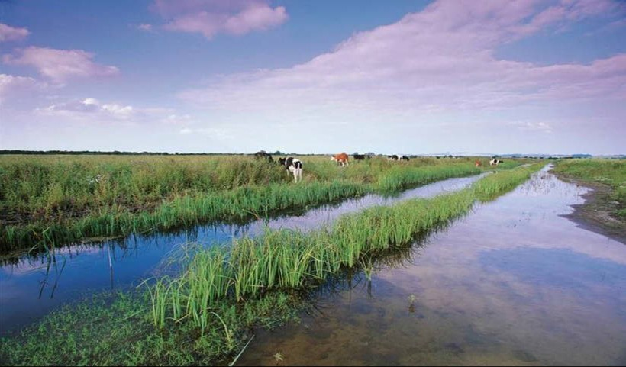

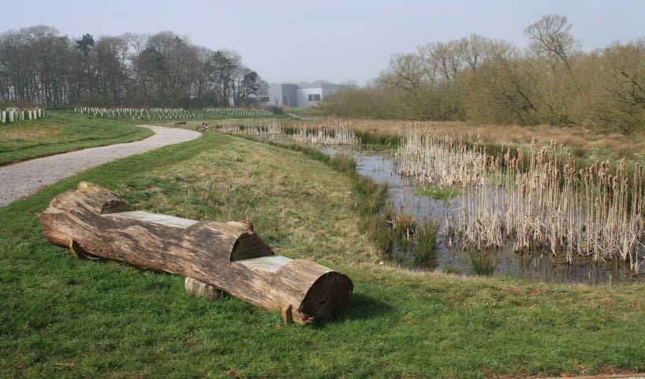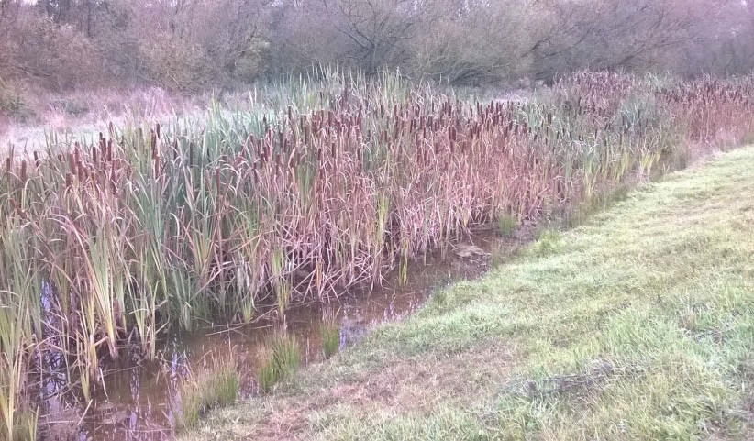

Appendix C
Planning Committee
Site Visit Protocol

Appendix C

Hydraulic Model Parameters

If you have used a hydraulic model in support of your SuDS application, please complete the tables below (as applicable) in order to assist the LLFA in their review.

C1 InfoWorks ICM / CS 1D SuDS Components

If you are representing SuDS components using 1D elements, please complete Table C1-1. If any SuDS components are modelled in 2D, please complete Table C1-2.

Model Parameter | Value | Justification for Choice / Link to Supporting Information
Boundary Conditions
Design Events Assessed
Storm Durations Assessed (minutes)
Critical Storm Duration Selected (minutes)
Soakaways
How many soakaways are included in the model?
Do all soakaways use the same SuDS parameters? If not, please supply the range of infiltration coefficients used in the boxes below.
Infiltration Loss Coefficient (mm/hr)
Porosity of Fill Material (voids volume / total volume)
Ponds
How many ponds are included in the model?
Do all ponds use the same SuDS parameters? If not, please supply the range of infiltration coefficients used in the boxes below.

Model Parameter |  |  | Value | Justification for Choice / Link to Supporting Information
Infiltration Loss (mm/hr) | Coefficient
Swales
How many swales included in the model? |  | are
Do all swales use the same SuDS parameters? If not, please supply the range of infiltration coefficients used in the boxes below.
Have you specified different infiltration loss rates for the sides and base?
Infiltration Loss Coefficient (base) (mm/hour)
Infiltration Loss Coefficient (side) (mm/hour)
Permeable Pavements
How many permeable pavements are included in the model?
Do all permeable pavements use the same SuDS parameters? If not, please supply the range of porosity values used.
Porosity of Fill Material (voids volume / total volume)

Table C1-1 InfoWorks 1D SuDS Components

C2 InfoWorks ICM / CS 2D SuDS Components

Model Parameter | Value | Justification for Choice / Link to Supporting Information
2D Infiltration Zones
What SuDS components have you represented using 2D infiltration zones?

Model Parameter | Value | Justification for Choice / Link to Supporting Information
Which infiltration model have you used? (Constant / Fixed / Horton)
Constant Infiltration Model
Have you used the same infiltration loss coefficient for all 2D infiltration zones? If not, please supply the range of infiltration coefficients used in the boxes below.
Infiltration Loss Coefficient (mm/hour)
Fixed Infiltration Model
Have you used the same runoff coefficient for all 2D infiltration zones? If not, please supply the range of runoff coefficients used in the boxes below.
Runoff Coefficient
Horton Infiltration Model
Have you used the same coefficients for all 2D infiltration zones? If not, please supply the range of runoff coefficients used in the boxes below.
f0 (Initial infiltration rate in mm/hour)
fC (Final infiltration rate in mm/hour)
K
Soil Moisture Storage
Initial Soil Moisture Water Content

Table C1-2 InfoWorks 2D SuDS Components

C3 Micro Drainage Source Control SuDS Components

If you are representing SuDS components using MicroDrainage, please complete Table C1-3.

Model Parameter | Value | Justification for Choice / Link to Supporting Information
Boundary Conditions
Design Events Assessed
Storm Durations Assessed (minutes)
Summer and Winter Cv
Site Information
Site Area (hectares)
Volumetric Runoff Coefficient
Time of Concentration (minutes)
Storage Volume in Pipe Network (m³)
Time Area Diagram
Green Roofs
How many green roofs have been used?
Do all green roofs use the same SuDS parameters? If not, please supply the range of values used in the boxes below.
Roof area (m²)
Depression storage (m³)
Evapotranspiration (assumed rate)
Decay coefficient

Model Parameter | Value | Justification for Choice / Link to Supporting Information
Infiltration
How many infiltration structures have been used?
Do all structures used the same infiltration parameters? If not, please supply the range of values used in the boxes below.
Infiltration Loss Coefficient (base) (mm/hour)
Infiltration Loss Coefficient (sides) (mm/hour)
Porous Car Park
How many porous car parks have been used?
Do all car parks use the same parameters? If not, please supply the range of values used in the boxes below.
Membrane percolation
Porosity
Depression Storage
Evaporation
Soakaway
How many soakaways are included in the model?
Do all soakaways use the same parameters? If not, please supply the range of coefficients used in the box below.
Porosity

Model Parameter | Value | Justification for Choice / Link to Supporting Information
Infiltration Trench
How many infiltration trenches are included in the model?
Do all infiltration trenches use the same parameters? If not, please supply the range of coefficients used in the box below.
Porosity
Cellular Storage
Does all your cellular storage use the same porosity value? If not, please supply the range of coefficients used in the box below.
Porosity

Table C1-3 MicroDrainage SuDS Components

For more information please contact:

Flood Risk Planning Staffordshire County Council No.2 Staffordshire Place Tipping Street
Stafford ST16 2DH
E-mail: flood.team@staffordshire.gov.uk

