Sustainable Drainage Systems (SuDS) Handbook

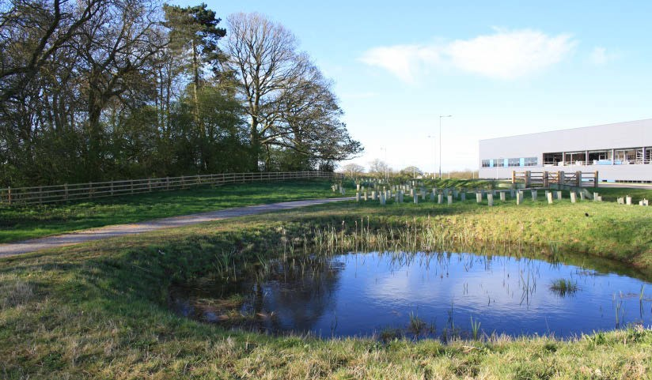
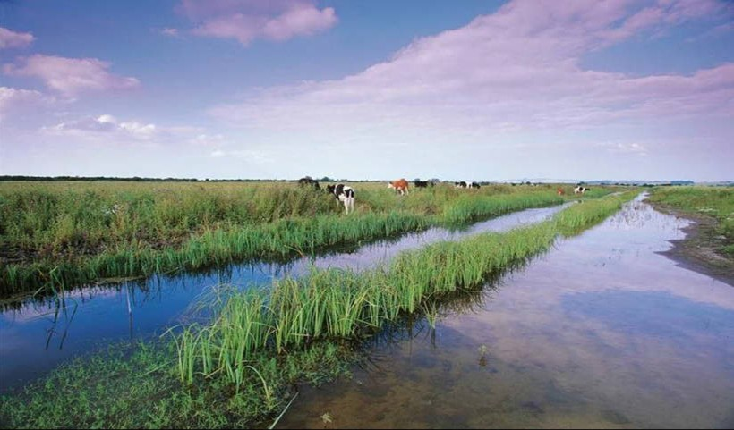

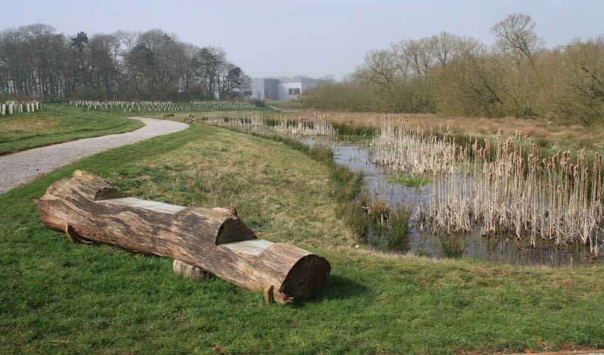
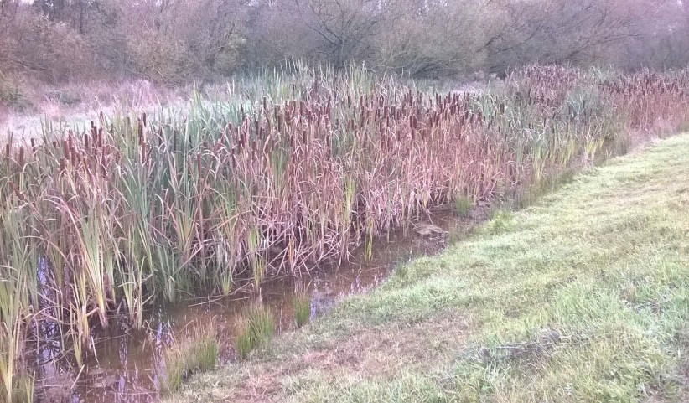

Appendix A
Planning Committee
Site Visit Protocol

Appendix A

Surface Water Drainage Proforma

The table below sets out the evidence required within the SuDS submission to demonstrate that both the National Standards and Local Standards have been complied with. The developer should complete the highlighted text boxes in the proforma.

(* dependent on options for surface water disposal, ** at outline stage it should be demonstrated that consideration has been given to how the SuDS scheme will be maintained throughout its lifetime, ***at outline stage it should be demonstrated that access is feasible)

Applicant Name

Planning Application Name

Application Type (please circle) Outline Full

1. Site Context

Complied With? Evidence Supplied
Required for
Outline Planning
Required for Full
Planning

Evidence Required

1.1 Site location plan | Y | Y

1.2 Detailed site layout plan at an identified scale with a north arrow |  | Y
1.3 Topographical survey of the site, including cross sections of any adjacent watercourses for an appropriate distance upstream and downstream of the proposed discharge point |  | Y
1.4 Survey and assessment of Environmental Constraints (identified historic (designated and undesignated), ecological (designated sites, habitats and species) and tree constraints and landscape context. |  | Y

- Design Principles

Local Standards

Local Standard A – Phased Development and Drainage Strategies

For phased developments, the LLFA will expect planning applications to be accompanied by a Drainage Strategy which takes a strategic approach to drainage provision across the entire site and incorporates adequate provision for SuDS within each phase.

Local Standard B – Pollution Prevention and Control

The LLFA will expect the SuDS to demonstrate how pollutants are prevented or controlled as part of the SuDS scheme. This should include consideration of the sensitivity of receiving waterbodies and particular attention should be given to the first 5mm of rainfall (‘first flush’ that mobilises the most pollutants).

Local Standard C – Conformity with the SuDS Management Train Principles

The LLFA will expect the SuDS design to demonstrate how the principles of the SuDS Management Train have been taken into account Local Standard O – Multiple Benefits
The LLFA will expect the SuDS design to demonstrate, where appropriate, how environmental site constraints have been considered and how the features design will provide multiple benefits e.g. landscape enhancement, biodiversity, recreation, amenity, leisure and the enhancement of historical features.

Required for
Outline Planning
Required for Full
Planning

2.1 Concept drainage strategy and masterplan demonstrating how SuDS have been incorporated into the site design and how the SuDS system complies with the SuDS Management Train | Y | Y
2.2 Demonstration that a suitable route for disposal of surface water is feasible and that relevant ‘in principle’ permissions have been granted. | Y
2.3 Plan of the proposed drainage system showing catchment areas including impermeable areas and phasing |  | Y
2.4 Review of multiple benefits provided by the SuDS scheme using the BeST Tool or another method as appropriate | Y | Y
2.5 Development phasing plan demonstrating how the SuDS scheme will be implemented |  | Y
2.6 Plan showing any existing drainage pathways on the site (including surface water flow paths, ditches, depressions and watercourses and historic drainage features such as drains, leats, water meadows, culverts etc.) and information as to how these are to be incorporated / managed within the wider SuDS scheme. | Y | Y

2.7 Long sections and cross sections for the proposed SuDS system |  | Y
2.8 Details of connections (including flow control devices) to watercourses, sewers, public surface water sewers and highway drains | Y | Y
2.9 Results of ground investigations or desk top studies / permeability assessment, including infiltration testing where appropriate | Y* | Y
2.10 Assessment of SuDS system water quality performance | Y | Y
2.11 Landscape planting scheme where a vegetated SuDS scheme is proposed |  | Y

- Peak Flow Control

Applicable National Standards

S2 For greenfield developments, the peak runoff rate from the development to any highway drain, sewer or surface water body for the 100% Annual Exceedance Probability rainfall event and the 1% Annual Exceedance Probability rainfall event should never exceed the peak greenfield runoff rate for the same event.

S3 For developments which were previously developed, the peak runoff rate from the development to any drain, sewer or surface water body for the 100% Annual Exceedance Probability rainfall event and the 1% Annual Exceedance Probability rainfall event must be as close as reasonably practicable to the greenfield runoff rate from the development for the same rainfall event, but should never exceed the rate of discharge from the development prior to redevelopment for that event.

Required for
Outline Planning
Required for Full
Planning

3.1 Details of pre and post development runoff rates for 100% and 1% Annual Exceedance Probability rainfall events sufficient to demonstrate that the proposed SuDS system should operate as designed | Y | Y
3.2 Full design calculations to demonstrate conformity with the national non-statutory technical standards for SuDS and Local Standards |  | Y

- Volume Control

Applicable National Standards

S4 Where reasonably practicable, for greenfield development, the runoff volume from the development to any highway drain, sewer or surface water body in the 1% Annual Exceedance Probability, 6 hour rainfall event should never exceed the greenfield runoff volume for the same event.

S5 Where reasonably practicable, for developments which have been previously developed, the runoff volume from the development to any highway drain, sewer or surface water body in the 1% Annual Exceedance Probability, 6 hour rainfall event must be constrained to a value as close as is reasonably practicable to the greenfield runoff volume for the same event, but should never exceed the runoff volume from the development site prior to redevelopment for that event.

S6 Where it is not reasonably practicable to constrain the volume of runoff to any drain, sewer or surface water body in accordance with S4 or S5 above, the runoff volume must be discharged at a rate that does not adversely affect flood risk.

Local Standards

Local Standard E – Climate Change

The LLFA will expect SuDS design to include an allowance for a 20 - 30%* increase in rainfall for a 1% Annual Exceedance Probability rainfall event in order to accommodate the 2016 Upper End climate change predictions. (*note that guidance may be subject to change and therefore the most up to date information should be referenced / clarification sought from the LLFA)

Local Standard F – Urban Creep

The LLFA will expect the SuDS design to include an allowance for an increase in impermeable area to accommodate urban creep as set out in the SuDS Handbook.

Local Standard G – Emergency Overflows

The LLFA will expect an emergency overflow to be provided for piped and storage features above the predicted water level in a 1% Annual Exceedance Probability rainfall event, with an allowance for climate change

Local Standard H – Freeboard Levels

The LLFA will expect all surface water storage ponds to provide a 300mm freeboard above the predicted water level arising from a 1% Annual Exceedance Probability rainfall event inclusive of an allowance for climate change. Care must be taken to ensure that excavations do not take place below the ground water level.
Required for
Outline Planning
Required for Full
Planning

Evidence Required
Complied With? Evidence Supplied

4.1 Details of pre and post development runoff volumes for 1% Annual Exceedance Probability rainfall events plus an allowance of 30% for climate change and up to a 10% increase in impermeable area to account for urban creep. | Y | Y
4.2 Drawings showing location, dimensions and levels of emergency overflows provided for piped and storage features. |  | Y

- Flood Risk Within the Development

Applicable National Standards

S7 The drainage system must be designed so that, unless an area is designated to hold and/or convey water as part of the design, flooding does not occur on any part of the site for a 3.3% Annual Exceedance Probability rainfall event.

S8 The drainage system must be designed so that, unless an area is designated to hold and/or convey water as part of the design, flooding does not occur during a 1% Annual Exceedance Probability rainfall event in any part of: a building (including a basement); or in any utility plant susceptible to water (e.g. pumping station or electricity substation) within the development.

S9 The design of the site must ensure that, so far as is reasonably practicable, flows resulting from rainfall in excess of a 1% Annual Exceedance Probability rainfall event are managed in exceedance routes that minimise the risks to people and property.

Local Standards
Local Standard D – Exceedance Flows

The LLFA will expect exceedance flows, originating from both within and outside of the development site, must be directed through areas where the risks to both people and property are minimised.

When considering exceedance routes, particular attention should be paid to

  - The position of walls, bunds and other obstructions that may direct water but must not cause ponding

  - The location and form of buildings (e.g. terraces and linked detached properties) that must not impede flows or cause ponding

  - The finished floor levels relative to surrounding ground Local Standard I – Watercourse Floodplains
The LLFA will expect the floodplains of ordinary watercourses to be mapped to an appropriate level of detail considering the nature of the application (i.e. detailed flood modelling should be undertaken to support full planning applications). The layout of the development will then take a sequential approach, siting the least vulnerable parts of that development in the highest flood risk areas.

Local Standard J – Retention of Natural Drainage Features

The LLFA will expect natural drainage features on a site should be maintained and enhanced. Culverting of open watercourses will not normally be permitted except where essential to allow highways and / or other infrastructure to cross. In such cases culverts should be designed in accordance with CIRIA’s Culvert design and operation guide, (C689).

Where a culverted watercourse crosses a development site, it should be reverted back to open channel. In such a case the natural conditions deemed to have existed prior to the culverting taking place should be re-instated.

Local Standard K – Impact of Downstream Water Levels

If high water levels within a receiving watercourse into which a SuDS scheme discharges are anticipated, the LLFA will expect that they will not adversely affect the function of that SuDS system.

Required for
Outline Planning
Required for Full
Planning

5.1 Details showing that the drainage is sufficient to accommodate a 3.3% Annual Exceedance Probability rainfall event |  | Y
5.2 Details showing that flooding does not occur in a building or susceptible utility plant in a 1% Annual Exceedance Probability rainfall event including appropriate allowances for climate change and urban creep. |  | Y
5.3 Details of exceedance flow routes designed to minimise flood risk to people and property. Flow routes should also account for any potential blockage of structures. |  | Y
5.4 Drawings identifying sources of water entering the site pre development | Y | Y
5.5 Drawings demonstrating how surface water flows are routed through the site pre development i.e. existing channels and culverts | Y | Y
5.6 Drawings demonstrating how surface water flows are routed through the site post development including opportunities for daylighting existing culverts | Y | Y
5.7 Drawings identifying where surface water flows leave the site pre development | Y | Y

5.8 Drawings identifying where surface water flows leave the site post development | Y | Y
5.9 Plan demonstrating flooded areas for the 1% annual exceedance probability (1 in 100 annual chance) storm, including the appropriate allowance for climate change and urban creep, when the system is at capacity and illustrating flow paths for design for exceedance |  | Y
5.10 Plans showing the location of the Flood Zones associated with ordinary watercourses on the site | Y | Y
5.11 Assessment of the impacts of high water levels in receiving watercourses on the operation of SuDS scheme |  | Y
5.12 Copy of your Flood Risk Assessment (where required by the National Planning Policy Framework (NPPF)) (Please note that for those sites not requiring a FRA, the developer will be required to submit the other supporting information in this table to enable the LLFA to consider the proposed SuDS system in line with the National Standards and Local Standards.) | Y | Y

- Structural Integrity

Applicable National Standards

S10 Components must be designed to ensure structural integrity of the drainage system and any adjacent structures or infrastructure under anticipated loading conditions over the design life of the development taking into account the requirement for reasonable levels of maintenance.

S11 The materials, including products, components, fittings or naturally occurring materials, which are specified by the designer must be of a suitable nature and quality for their intended use.

Required for
Outline Planning
Required for Full
Planning

6.1 Technical specifications of drainage design components including design life |  | Y
6.2 Loading calculations for drainage system components |  | Y
6.3 Category 0 Approval for structures with a diameter greater than 900mm |  | Y

- Designing for Maintenance Considerations

Applicable National Standards

S12 Pumping should only be used to facilitate drainage for those parts of the site where it is not reasonably practicable to drain water by gravity.

Local Standards

Local Standard L – Maintenance Requirements

The LLFA will expect SuDS to be designed so that they are easy to maintain. Proper use of the SuDS management train, including surface features, is one way to achieve this.

The developer must set out who will maintain the system, how the maintenance will be funded and provide a maintenance and operation manual. Local Standard M – Minimising the Risk of Blockages
The LLFA will expect the SuDS design to minimise the risk of blockage as far as is reasonably possible e.g. by using suitable pipe sizes and making underground assets as visible and accessible as possible.

Local Standard N – Use of Pumped Systems

If it can be demonstrated that a partial or completely pumped drainage system is the only viable option, the LLFA will expect the residual risk of flooding due to the failure of the pumps to be assessed. The design flood level must be determined under the following conditions
- If the pumps were to fail,

- If the attenuation storage was full,

- If a design storm occurred.

The finished floor levels of the affected properties should be raised above this flood level and all flooding safely stored onsite.

An emergency overflow must be provided for piped and storage features above the predicted water level arising from a 1% Annual Exceedance Probability rainfall event inclusive of allowances for climate change and urban creep.
Required for
Outline Planning
Required for Full
Planning

Evidence Required
Complied With? Evidence Supplied

7.1 Justification for use of pumps within a SuDS scheme where applicable | Y | Y

7.2 Maintenance and Operation Manual for the SuDS Scheme at an appropriate level of detail. To include as a minimum responsible party and funding method | Y | Y
7.3 Management plan and proposed contractual arrangements for the management of the drainage scheme over its lifetime | Y** | Y
7.4 Maintenance access arrangements for all proposed drainage systems | Y*** | Y
7.5 Operational characteristics of any mechanical features including maintenance and energy requirements |  | Y
7.6 Risk assessment demonstrating how the risk of blockages has been minimised |  | Y
7.7 Assessment of residual flood risk in the event of pump failure based on parameters above. |  | Y

- Construction

Applicable National Standards

S13 The mode of construction of any communication with an existing sewer or drainage system must be such that the making of the communication would not be prejudicial to the structural integrity and functionality of the sewerage or drainage system.

S14 Damage to the drainage system resulting from associated construction activities must be minimised and must be rectified before the drainage system is considered to be completed.

Evidence Required
Complied With? Evidence Supplied

Required for
Outline Planning
Required for Full
Planning

8.1 Construction drawings prepared by a suitably competent Engineer giving details of proposed elevations, dimensions, materials to be used and detailing how the proposed SuDS scheme will connect to an existing drainage system. |  | Y
8.2 Plan for the management of construction impacts including any diversions, erosion control, phasing and maintenance period (pre adoption) |  | Y
8.3 Construction Health and Safety Plan where appropriate. This should be in proportion to the risks involved in the project. Reference may be made to the HSE considering in particular open water, confined spaces and underground services |  | Y
8.4 Details of any offsite works required, together with any necessary consents |  | Y
8.4 Risk assessment which demonstrates how the construction methodology will minimise damage to existing assets. |  | Y
8.6 Contingency plan which demonstrates how any damage to existing assets will be resolved. |  | Y

Land Searches

The following information is required in order that a response to future Land Search requests submitted to the Local Planning Authority can be supplied as appropriate.

Question | Answer | Supporting Documentation Required
1. Will all properties on the development be served by a SuDS system? | Yes / No | If no, please identify on a plan or by address, those properties which are served by a SuDS system.
2. Do any properties on the development have SuDS features within their boundary? | Yes / No | Please identify on a plan, or by address, properties which have SuDS features within their boundary.  For the properties identified, please highlight those for which the owner is responsible for the maintenance.
3. Do any properties benefit from a SuDS system for which there is a charge? | Yes / No | For those properties benefiting from a SuDS system for which there is a charge, please state who is responsible for billing the property for this charge.

Page Intentionally Blank

For more information please contact:

Flood Risk Planning Staffordshire County Council No.2 Staffordshire Place Tipping Street
Stafford ST16 2DH
E-mail: flood.team@staffordshire.gov.uk

