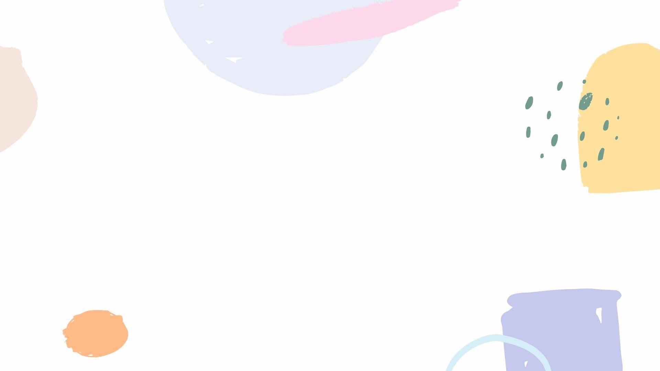
Easy Read
Staffordshire’s Special Educational Needs and Disabilities Strategy Stafford
2021 - 2026
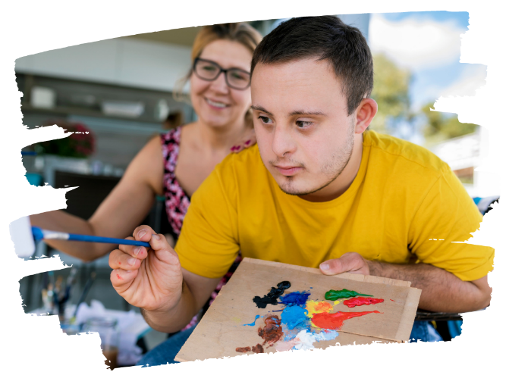
We want to help children and young people with Special Educational Needs and Disabilities to get the help they need.
We want all children and young people with SEND to believe that they can be their best and achieve their goals.
We want all children and young people with SEND to get the right help, at the right time.
They will get help from their parents, the community and the professionals that work with them.
We will make sure that…
- Everyone who helps a child or young person with send works better together.
- Children and young people with SEND can get the right help at the right time
- Children and young people with SEND can easily get involved in their community
- Children and young people with SEND are helped to plan their future

We will know that we have done a good job if…
- Children and parents feel listened to
- Children can go to a local school and get the right help
- Schools are a friendly place for children with SEND
- Parents are happy that schools can give their child the help they need
- All Education Health and Care Plans are ready in 20 weeks
- Less Education Health and Care Plans are needed because help is given early.
- Children with SEND are able to do things in their community with their friends
- Parents get the help they need
- Professionals and parents work together to make things better.
- Our children are happy to do things on their own and feel excited about growing up.

