SEND Enhanced Resource Bases in Mainstream Schools

Introductory Information

Introductory Information

Staffordshire County Council (SCC) is seeking expressions of interest from Staffordshire mainstream schools to manage a SEND ERB or a Sensory ERB (SERB) on their school site.

Special Educational Needs and Disability (SEND) Enhanced Resource Bases (ERB) are part of Staffordshire County Council’s approach to ensuring that children and young people with an EHCP and significant additional SEND needs can have those needs met within their local mainstream school alongside their peers. Sensory ERBs will provide comprehensive, inclusive support for children and young people with an EHCP and with severe to profound sensory loss who can access a mainstream curriculum but require specialist provision.

The ERB is a central space within a mainstream school which provides specialist support for children and young people with significant additional SEND needs while maintaining their connection to a mainstream setting and allowing for access to mainstream lessons.
The core principles of an ERB are:
- inclusion
- individualised learning
- specialist staffing and resource
- supported transition
Applications are being sought for:
- SEND ERB’s to cover primary and secondary stages of education and to enable coverage across all Staffordshire districts
- A county wide Sensory ERB.

Expressions of interest are particularly welcomed from mainstream schools who want to develop a partnership with a special school to help deliver and manage the ERB.

All proposed space for an ERB must be within accommodation at the mainstream school, which is surplus i.e. not required to meet the needs of the current and determined Published Admission Number (PAN). As part of the evaluation process Expressions of Interest will be reviewed by the School Organisation Team and Strategic Property in terms of both sufficiency and suitability requirements for the school.

How the ERBs will work alongside other support for children and young people with SEND is outlined in the diagram below.

Tiers of Support
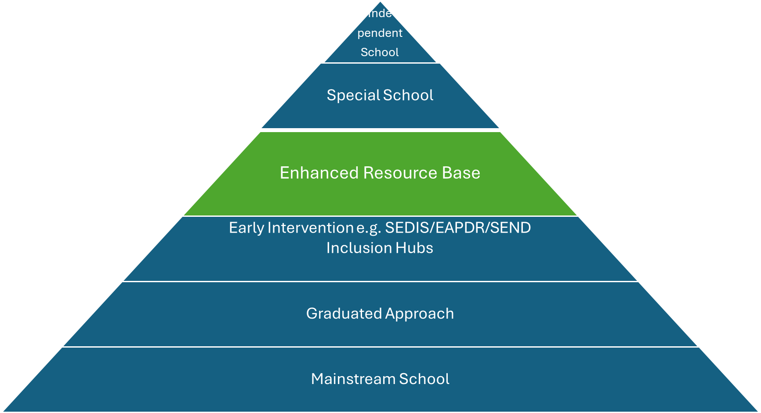
Successful applications to provide and ERB will be expected to enter into a legal Service Level Agreement with Staffordshire County Council for the delivery of the resource.

Key Dates
Service Specification and expressions of interest form available | 23 February 2026
Invitation to submit Expressions of Interest | 23 February 2026– 12 noon, 17 April 2026
Stage 1 - Evaluation of applications | 20 April 2026 – 30 June 2026
Stage 2 - Interviews with potential schools | July – Sept 2026
Successful school informed | 30 September 2026
Phase 1 Enhanced Resource bases open | Summer term 2027
Phase 2 Enhanced Resource bases open | September 2027
(Please note: these dates are indicative and may be subject to change)

The documents available include:

- Enhanced Resource Bases Introductory Information (this document)
- Service specification for a SEND ERB – this provides detailed information on the requirements of the SEND ERB
- Service specification for a Sensory ERB– this provides detailed information on the requirements of the SERB
- Evaluation matrix – outlining the scoring criteria for applications

Applications must be submitted by 12 noon on 17 April 2026 to educationcommissioning@staffordshire.gov.uk with the title: Enhanced Resource Base Expression of Interest form .

Any clarifications or questions should be sent to: educationcommissioning@staffordshire.gov.uk

