Service Specification

for the provision of

SEND Enhanced Resource Bases in Mainstream Schools

Staffordshire County Council January 2026

CONTENTS

 | Title | Page
1.0 | INTRODUCTION | 3
 | 1.1 Statement  1.2 Background | 3  3
2.0 | THE SERVICE | 6
 | 2.1 Aims and Objectives of Service  2.2 Service Description  2.3 Eligibility  2.4 Placement  2.5 Transition  2.6 Funding and Resources  2.6 Transport | 6  6  8  8  9  10  10
3.0 | OPERATIONAL SERVICE REQUIREMENTS | 10
 | 3.1 Staffing  3.2 Professional Development  3.3 Partnership and Engagement  3.4 Policy Context  3.5 Monitoring and Evaluation | 10  11  11  13  15

- Introduction

  - Statement

    - Staffordshire County Council (SCC) is seeking expressions of interest from Staffordshire mainstream schools to manage a Special Educational Needs and Disability (SEND) Enhanced Resource Base (ERB) on their site.

    - Applications are being sought for ERB’s to cover primary and secondary stages of education and to enable coverage across all districts of Staffordshire.

    - Expressions of interest will be especially welcomed from mainstream schools who want to develop a partnership with a special school to manage the ERB.

    - All proposed space for an ERB must be within accommodation at the mainstream school, which is surplus i.e. not required to meet the needs of the current and determined Published Admission Number (PAN). As part of the evaluation process Expressions of Interest will be reviewed by the School Organisation Team and Strategic Property in terms of both sufficiency and suitability requirements for the school.

  - Background

Local Context

1.2.1.1 Staffordshire is a large Local Authority, divided into eight districts: Cannock Chase, East Staffordshire, Lichfield, Newcastle, South Staffordshire, Stafford, Staffordshire Moorlands and Tamworth.

Figure One: Map of Staffordshire Districts
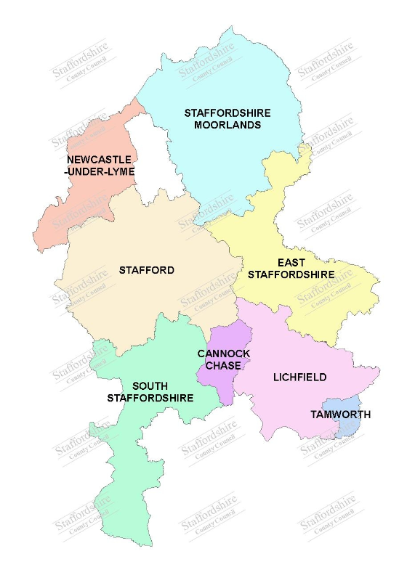

1.2.1.2 Staffordshire has 411 schools, 23 Special schools, 6 Pupil Referral Units (PRUs) and 4 Further Education (FE) colleges.

1.2.1.3 The county also has 4 Primary Early Intervention Resource Bases, 3 Autistic Spectrum Condition Secondary Resource Bases, 1 SEND Resource Base and 1 Speech and Language Primary Resource Base.

1.2.1.4 There are 125,869 children and young people across all phases of education. 16,992 children on Special Educational Needs (SEN) Support and 9225 children with an EHCP (January 2026).

    - Strategic

Staffordshire’s SEND and Alternative Provision Strategy 2026-29, developed by Staffordshire County Council (SCC) and the Staffordshire and Stoke-on-Trent Integrated Care Board, sets out Staffordshire’s vision and outcomes for our children and young people with Special Educational Needs & Disabilities (SEND) and those who access Alternative Provision. It reflects the shared commitment across the local area partnership to improve experiences and outcomes for children and young people.

Key Priorities within the strategy focus on:

- providing timely and consistent support
- improving the timeliness and consistency of support by streamlining processes and strengthening early intervention pathways, with a focus on ensuring children and young people receive the right support at the right time, with consistently positive experiences across Staffordshire.
- listening, understanding and supporting families
- embedding co-production at every level and improving how we communicate with children, young people, and families.
- nurturing inclusive environments and best practice
- supporting professionals to access high quality training, resources, and peer support and promoting inclusive, flexible, education environments that recognise and respond to individual needs.

      - This specification was developed in consultation with a range of key stakeholders across the Staffordshire SEND partnership, including representation from health, Staffordshire Parent Carer Forum, SEND professionals, mainstream and special school leaders.

      - SEND ERBs are vital for promoting inclusivity, equality, and excellence in SEND provision in mainstream schools.

      - ERBs are part of Staffordshire County Council’s approach to ensuring that children and young people with significant additional SEND needs can have their SEND needs met so that they thrive in their local mainstream school alongside their peers and, that these schools are sufficiently resourced and supported by the SEND partnership.

      - Figure Two below illustrates the range of different provision available to support children and young people with SEND and the levels of support.

Figure Two: Tiers of Support

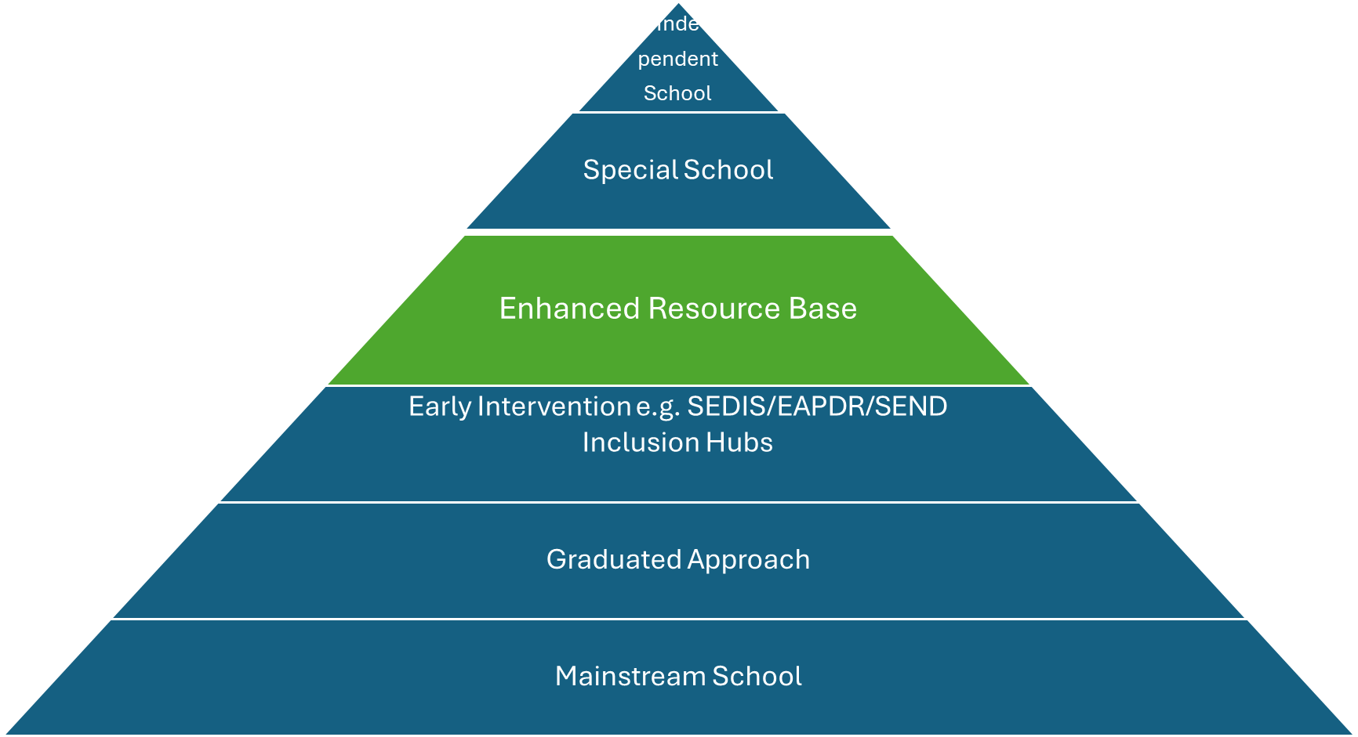

1.2.2.11 The specification outlines the essential features, operational standards, and best practices for SEND ERBs within mainstream schools.
- The Service

2.1 Aims and Objectives of Service

The intention is to create a countywide provision of SEND ERB’s within an inclusive mainstream setting, to meet the needs of children and young people with an Educational, Health and Care Plan (EHCP) from reception to year 11.

2.1.1 The aim of the ERB:

To provide an additional school placement option for children and young people with an EHCP which provides specialist support and enables access to the mainstream curriculum.
2.1.2 The objectives of the ERB are to provide:

- inclusive support for children and young people with significant additional SEND needs
- individualised tailored learning with access to an appropriately differentiated curriculum
- access to specialist staffing and resources
- access to mainstream teaching and environment as appropriate
- an appropriate school place close to their local community
- to facilitate effective transitions
2.1.3 At the heart of the ERB are the core principles:
- inclusion
- individualised learning
- specialist staffing and resource
- supported transition

2.2 Service Description

    - The ERB is a central space within a mainstream school which provides specialist support for children and young people with significant additional SEND needs while maintaining their connection to a mainstream setting and allowing for access to mainstream lessons.

    - The purpose of the ERB is to deliver tailored interventions, adapted teaching, and access to specialist staff and resources that cannot be fully achieved through the universal offer of the school.

    - The ERB will have smaller numbers of children and young people and smaller class sizes.

    - This approach supports positive outcomes for all children and young people by ensuring equity of access to education and reducing barriers to learning, whilst promoting inclusion through participation, social interaction and shared learning opportunities with the wider school community.

    - Curriculum and Learning Support

      - Specialist staff will work within the ERB providing adapted teaching and access to specialist resources.

      - Children and Young People accessing the ERB will have full access to the mainstream curriculum, albeit differentiated by process to meet their individual learning needs.

      - Each child or young person will have an individualised education plan (IEP), based on the outcomes and provision set out in their EHCP. IEPs will be coproduced with parents, carers, children, young people and support professionals.

      - The curriculum will be differentiated and accessible, allowing children and young people to participate in mainstream lessons where appropriate, with targeted support.

      - The ERB will make provision for suitable assistive technology (e.g., communication devices, tablets, software) to enhance learning and independence.

      - A key component of the ERB curriculum will be focussed on programmes designed to develop social skills, emotional resilience, and self-esteem. Approaches such as Raising the Attainment of Disadvantaged Youngsters (RADY) RADY, Trauma Informed and Restorative and Relational Practice will be integral to the delivery of this aspect of the curriculum.

      - All ERBs will implement the Educational Psychology Assessment Through Teaching intervention (EPATT) to accelerate progress in reading and maths.

      - The school will make available specialist provision for wrap-around provision, including breakfast clubs and after school social provision to ensure equal access for all children and young people on roll.

      - The ERB will explore links with local community sports and recreational clubs to provide access to extracurricular activities.

    - Physical Environment

      - ERBs will ensure that children and young people are able to access opportunities for outdoor learning.

      - The physical environment within the ERB will be designed to ensure that barriers to inclusion are removed or mitigated to ensure that children and young people are able to access the physical, social and learning environment.

      - All ERB facilities must be fully accessible to children and young people with physical disabilities. This may include, where appropriate, the provision of ramps, lifts, accessible toilets, and adjustable furniture.

      - ERBs should feature dedicated spaces such as quiet rooms, sensory areas, breakout spaces and access to outdoor space to accommodate diverse needs, such as sensory processing or emotional regulation.

      - The environment must be safe and secure but welcoming, with appropriate safeguarding measures and clear signage.

      - Spaces should be flexible so that they can adapt to support small group work, 1:1 intervention, and independent study.

  - Eligibility

Children and young people will:
- be aged between reception to Year 11
- have an Education, Health and Care Plan (EHCP)

  - Placement

    - Children and young people accessing the ERB will have an EHCP.

    - In Section I of the EHCP the Placement will name the ERB provision.

    - The Local Authority will consider whether to consult for a placement at the ERB as part of the EHCNA process or after an Annual Review at which a change of placement has been concluded. The decision to consult an ERB will be child and young person centred. However, the following factors will always be considered.

- the child or young person has a draft or final EHCP that is in the process of being re-drafted.
- schools will be consulted if the Local Authority deemed that they are the nearest and appropriate.
- parental preference indicates local ERB provision.
- the child or young person’s assessment typically indicates an Education Banding Tool level of between 5-7.
- the assessment indicates that the child or young person can access a broad and balanced mainstream curriculum with significant planning, adaptations and teaching.

2.4.4 Placements will be made in accordance with and correspond with the child or young person’s chronological age and year group. All placements will be full-time.

2.5 Transition

2.2.5.1 A structured induction process will be provided to all children and young people starting at the ERB to provide the support required for a positive transition to the setting. This will include all parties involved in supporting the child or young person (i.e. the child or young person, parents or carers, the current and new educational setting, ERB staff and all other professionals involved).

2.2.5.2 This induction will include an initial meeting with the parents and carers and child or young person to:

- understand the needs of the child/young person
- discuss the support and academic provision to be provided
- enable the child or young person to familiarise themselves with the new school environment and meet classmates

In addition:
- ERB professionals may visit the child or young person in their current education setting to conduct observations, gather evidence of need and speak to current school staff.
- visits for the child/young person prior to the start of the placement at the ERB may be arranged

2.2.5.3 On leaving the ERB, a structured support plan will be implemented to ensure a positive exit transition is completed. This will include:

- visits to the new education setting.
- staff from the new education setting will also be invited to the ERB to meet the child/young person and speak to ERB staff.

  - Funding and Resources

    - Resource bases will have secure, ring-fenced funding to ensure sustainability and continuous improvement. Funding will be based on the current methodology for the funding of academy and maintained special schools (£10K per place funding supplemented through top up identified through the child or young person’s EHCP).

    - ERB funding will be used to make provision for ERB staffing, specialist equipment, and professional development.

    - The mainstream school that the ERB is located in, should publish details of resource base funding and outcomes to demonstrate accountability.

2.7 Transport

2.7.1 For children and young people with an Education, Health and Care Plan (EHCP) Staffordshire will apply the same general eligibility criteria as other pupils. Having an EHCP or attending a special school or unit does not automatically result in the provision of free travel assistance.

- Operational Service Requirements

  - Staffing

    - All staff working in the ERB learning environment will have the professional skills and, a deep understanding of and commitment to the inclusion of children and young people who have a range of significant additional SEND needs which will be demonstrated through their practice.

    - Staff will be trained in Relational and Restorative Practice and Attachment and Trauma informed approaches.

    - The ERB will be led by a qualified teacher with additional qualifications/experience in SEND who reports directly to the SENCo or headteacher of the mainstream school. The Lead Teacher for the ERB will be supported by Specialist Teaching Assistants.

    - There will be an appropriately qualified Designated Safeguarding Lead within the mainstream school.

  - Professional Development

    - All staff in the ERB team will participate regularly in appropriate and ongoing training. This will include:

      - SEND focused training - including updates on legislation, best practices, and specific interventions.

      - Specific training to equip staff with the knowledge and skills to:

- implement the graduated approach to meeting needs effectively to support all children and young people
- provide a learning environment that utilises best practice guidance to support communication and sensory needs
- apply strategies and specific intervention plans to support:
- Speech, Language and Communication Needs (SLCN)
- Sensory processing needs
- Social, Emotional and Mental Health (SEMH)
- Fine and gross motor skills
- Medical needs

    - With their enhanced CPD, the ERB team have a collective role to build capacity, improve confidence and upskill the wider school community to meet the needs of all children with SEND in their school.
Regular input from speech and language therapists, occupational therapists, educational psychologists, and external agencies will ensure the best outcomes are achieved for all children and young people.

  - Partnership and Engagement

    - The Local Authority will ensure that all ERBs have a designated core offer of Educational Psychology and/or Specialist Teaching Service consultation. (TBC).

    - All specific health needs of the child or young person), including those detailed in their EHCP, will be met by the relevant services involved in their care.

    - Universal services such as the Mental Health Support Teams (MSHT), Staywell, and 0–19 service will be accessible in line with provision available for the mainstream school.

    - ERBs must develop a proactive offer that engages parents and carers, offering regular reviews, workshops, and support sessions.

    - ERBs, along with Local Authority Services must explore and develop partnerships with local organisations, charities, and businesses to enrich the ERB provision and promote inclusion beyond the school.

    - Person Centred approaches (e.g. Pearpoint et al 1991) will be key methodology to ensure children and young people have authentic opportunities to contribute to the development of the ERB and, coproduce their learning experience.

    - ERBs will link with a partner local academy or Local Authority maintained special school. This will provide opportunities for cross inclusion experiences, staff exchange, professional development and specialist consultation support.

    - ERBs should work closely with district SEDIS teams and SEND and Inclusion Hubs to share locality learning and facilitate district needs analysis, planning and delivery.

3.4 Policy Context

3.4.1 National Policy

The Provider/Recipient will adhere to relevant legislation, policies and guidance as amended from time to time. This will include but is not limited to:

- Children’s Wellbeing and Schools Bill 2024-25
- Working Together to Safeguard Children – A guide to inter-agency working to safeguard and promote the welfare of children (2023).
- Children and Families Act 2014
- SEND Code of Practice 2015
- Children and Social Work Act 2017
- Education Act 1996
- Education Act 2011
- Data Protection Act 2018
- General Data Protection Regulations 2018
- Health and Care Professions Council Standards of Conduct, Performance and Ethics (2016, updated edition in 2024).
- Equality Act 2010
- Keeping Children Safe in Education (KCSIE) (2015, updated edition in 2024)
- Safeguarding Vulnerable Groups Act 2006
- Human Rights Act 1998
- Health and Safety at Work Act 1974 and relevant health and safety regulations
- Care Act 2014

3.4.2 Local Policy

Strategy / Plan: | Outcomes / Priorities:
Staffordshire County Council Strategic Plan 2022 to 2026 | Outcome/s:  - Be healthier and independent for longer  Priorities:  - Encourage good health and wellbeing, resilience,  and independence  - Offer every Staffordshire child and young person the best start to life, and chance to achieve their potential
Staffordshire Families Strategic Partnership – Staffordshire’s Children, Young People and Families Strategy 2018-2028 | Outcome/s:  - Start well – every child has the best possible start in life to reduce differences in the quality of their health and wellbeing in the future.  - Grow well – all children and young people are supported to reach their potential so that they can have greater control over their lives  - Live well – children, young people and adults are supported to make good lifestyle choices.  Priorities:  - Happy and Healthy – encourage communities to be  more active and live healthier lifestyles; reduce  avoidable hospital admissions  - Safe and belonging – reduce infant and child mortality rates; improve parenting skills and aspirations
Staffordshire’s SEND and Alternative Provision Strategy 2026-29 | Key Priorities within the strategy focus:  - providing timely and consistent support  - listening, understanding and supporting families  - nurturing inclusive environments and best practice
Staffordshire County Council  Staffordshire Accessibility Strategy 2022-2026 | Priorities:  - Increase access to the curriculum for children and young people with disabilities.  - Improve the physical environment to increase access for children and young people with disabilities.  - Make information more accessible to children and young people with disabilities.

Living my Best Life - A Joint Strategy for Disabled and Neurodivergent people in Staffordshire 2023-2028 | Priorities:  - Staffordshire to become a place where people living with disabilities and neurodivergences can do what matters to them; where they feel valued and treated as equals in all aspects of society.  Outcome/s:  - Staffordshire is more open and equal for everyone.  - Stronger partnerships that are built around and include disabled and neurodivergent people.  - Disabled and neurodivergent people can say what they need and get support to make it happen.  - Disabled and neurodivergent people and their carers have more information and control  - Health and Social Care services will think about all the person’s needs and what they can do.

  - Monitoring and Evaluation

    - School Oversight

      - The ERB will provide a regular report to the school governing body through the SEND governor.

      - The effectiveness of the resource base will be evaluated termly by the school Senior Management Team, with input from staff, children and young people, and parents and carers.

      - Individual progress will be tracked using robust data systems, informing ongoing development and resource allocation.

      - Schools should seek external validation (such as accreditation, Ofsted inspections) for their SEN provision. This could include engaging with the Local Authority Whole School SEND Profile.

    - Local Authority Oversight

      - The Local Authority will establish a countywide SEND ERB Steering Group. This countywide SEND ERB Steering Group will agree a quality assurance (QA) framework that will be used as the basis to monitor outcomes of children and young people, improve practice and maintain equity of service delivery across the county.

      - The QA framework developed will be completed by the ERB on a termly basis and submitted to the Local Authority.

      - The group will also provide termly opportunities for collaborative solution finding and CPD input to support the embedding and development of ERBs across the county.
      - The Local Authority will undertake periodic audits of the Service. These audits may include, but not be limited to, a review of:

- The demand for the Service.
- The effectiveness of the Service in meeting the needs of children and young people
- Quality of the Service.
- Service User feedback.
- Stakeholder feedback.

