Staffordshire Enhanced Resource Base
EXPRESSION OF INTEREST FORM
A: INTRODUCTION
Enhanced Resource Bases (ERB) are part of Staffordshire County Council’s strategy to ensure that children and young people with significant additional special educational needs can thrive in their local mainstream school alongside their peers.

The intention is to create a countywide provision of Special Educational Needs and Disabilities (SEND) ERBs, for children and young people from reception to year 11, to meet the needs of children and young people with an Educational, Health and Care Plan (EHCP) within an inclusive mainstream setting.

The ERB is a central space within a mainstream school providing specialist support for children and young people with significant additional SEND needs while maintaining their connection to a mainstream setting and allowing for access to mainstream lessons.
Figure One below illustrates the range of different provision available to support children and young people with SEND and the levels of support.

Figure One: Tiers of Support
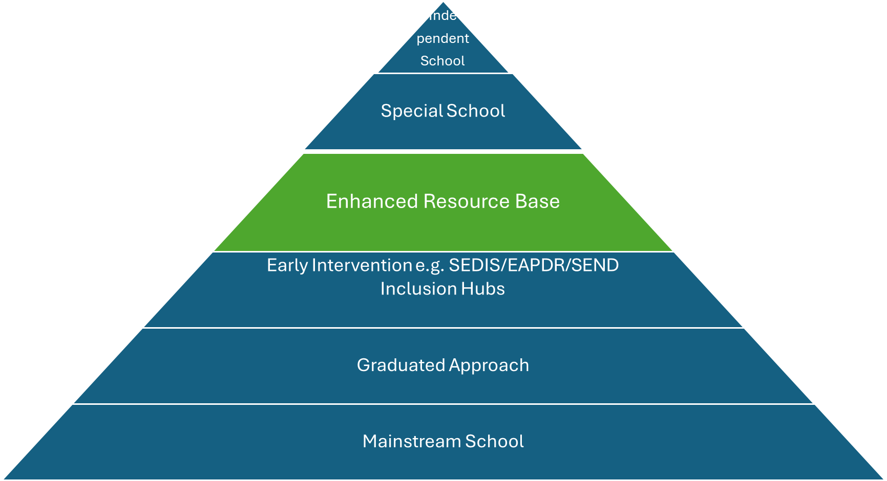

Applications must be submitted by 12 noon on 17 April 2026 to Educationcommissioning@staffordshire.gov.uk

B. CONTACT DETAILS
Name of Mainstream School:

Address of School
Lead contact:
Job Title:

Email:
Phone Number:
Name of Partner Special School:

C: OUTLINE OF ERB
C1. District of school

C2. Number of places to be offered in at the Enhanced Resource Base for each Key Stage?
Primary |  |  |  | Secondary
Reception | Key Stage One |  | Key Stage Two | Key Stage Three | Key Stage Four

C3. Provide a description of the Proposal

Please refer to district and/or County specific data in your answer Include:
Why you are applying to offer an ERB
Why do you feel the school should have an ERB
How will the ERB run alongside the mainstream school
How will the ERB meet the needs of the local community

D: QUALITY OF DELIVERY
D1. Latest Ofsted judgement of the mainstream school and special schools/other schools involved in the ERB.
Provide main Ofsted report findings in terms of inclusive practices and supporting children and young people with SEND.

D2. Achievement of Outcomes
- Detail outcomes achieved for children and young people within the school
- Detail outcomes achieved for children and young people with an EHCP/receiving SEND support
(Include: Attendance/Absence/Long-term absence levels, Performance data, progress data, Post 16 destinations, Post 16 NEET)
D3. Staffing
3a. Provide details of the proposed staffing for the ERB
3b. Outline the skills, training and experience of the proposed ERB staff
D4. Partnership Working
4a. How will the school be supported by the local special school
4b. Provide details of partnership working with all other practitioners/organisations

E: INCLUSIVE PRACTICE
Provide evidence to demonstrate your commitment to inclusive practice.
E1. Provide information for 2024/25
 | Numbers | Rate
Permanent exclusions
Fixed term exclusions
Part-time timetables
Managed moves to other schools
Number of pupils moved to Elective Home Education
E2. Provide the background and context to the data provided above:

E3. Provide examples of the school’s current Inclusion Practices:
Include: evidence of implementation of strategies and their impact, inclusion quality marks, relational and restorative approaches
E4. Provide information on embedding relational and restorative practices across the school and how these practices would be embedded within the ERB
E5. How will children and young people attending the ERB be integrated within the mainstream school

F: CHILDREN/YOUNG PERSONS AND PARENTS VOICE
F1. How will the ERB ensure the child/young person’s voice informs delivery?
F2. How will the ERB involve the parents/carers?
TRANSITION
F3. How will children/young people and parents be involved in transition into the ERB and the induction processes?

F4. How will children/young people and parents be involved in transition from the ERB and the Exit processes?

G. FINANCIAL AND PHYSICAL
G1. How accessible is the school location
Include whether this is accessible by public transport

G2. Provide details of the proposed space for the ERB (this must be surplus i.e. not required to meet the needs of the current and determined Published Admission Number (PAN).)
Include: room(s) to be utilised and current use of the room(s), room reference, location on the school site (accompanied by a plan showing the current and proposed accommodation), accessibility and suitability of the environment for children and young people with SEND.
Please note that if this information is not supplied the expression of interest will not be considered until the information is provided.

G3. Will the ERB be ready to use now and if not, what changes are required, timeframes for completion and how these costs will be met.

Applications must be submitted by 12 noon on 17 April 2026 to Educationcommissioning@staffordshire.gov.uk with the title: Enhanced Resource Base Expression of Interest form

